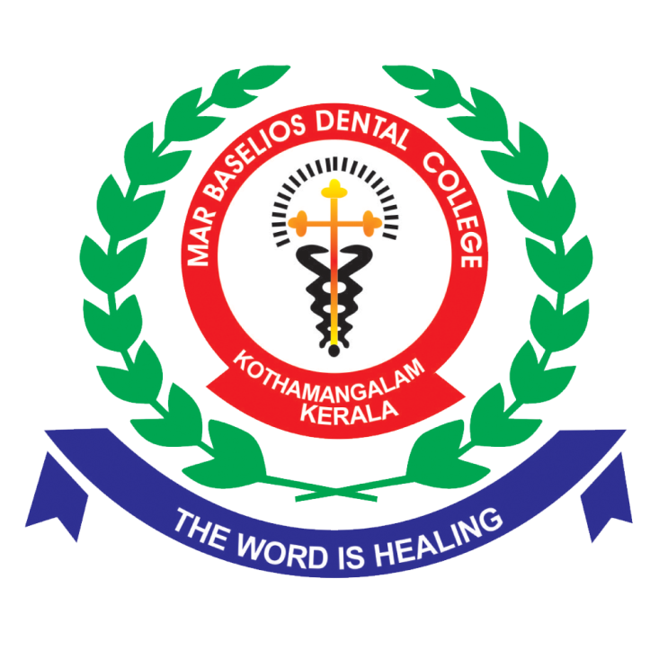

**Medical Benefits**

As part of its commitment to staff well-being, MBDC provides comprehensive medical benefits to its employees. These benefits include free periodic medical check-ups, free vaccinations, and other facilities aimed at safeguarding the health of staff members and their families.