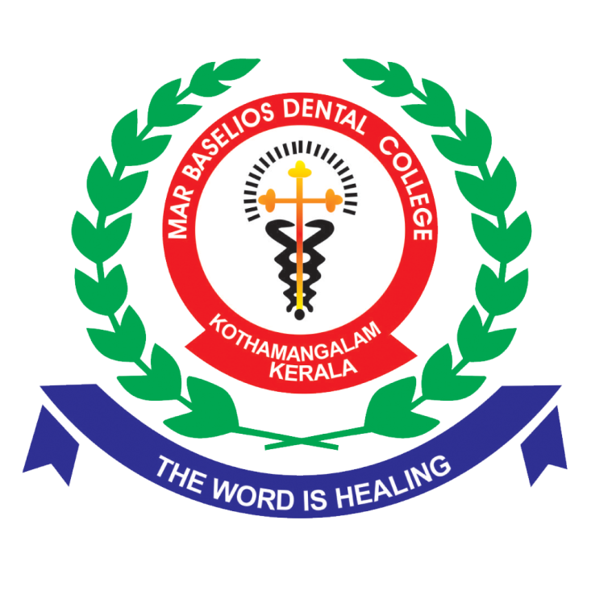

**Training**

The institution undertakes regular training programs for both teaching and non-teaching staff in academic, clinical, and administrative domains for keeping abreast with the current developments and trends in the respective fields. Teaching faculty are given opportunities to attend continuing dental education programmes to update their knowledge and skills.