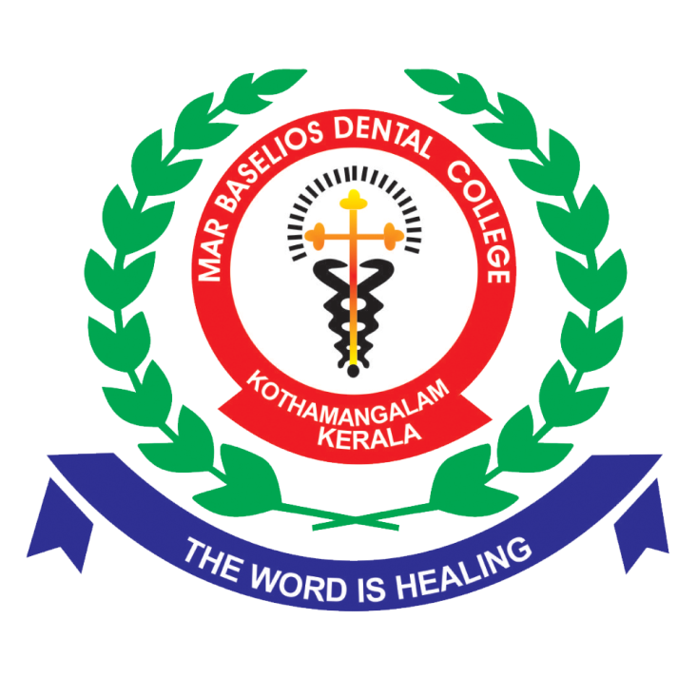

**Promotion**

MBDC recognizes the importance of career growth for its teaching staff. Promotion to higher positions is based on the availability of vacancies and the fulfillment of eligibility criteria set by regulatory bodies such as the Dental Council of India (DCI) and the Kerala University of Health Sciences (KUHS). In instances where vacancies are not available, the faculty's performance appraisal can lead to additional increments, motivating continuous improvement.