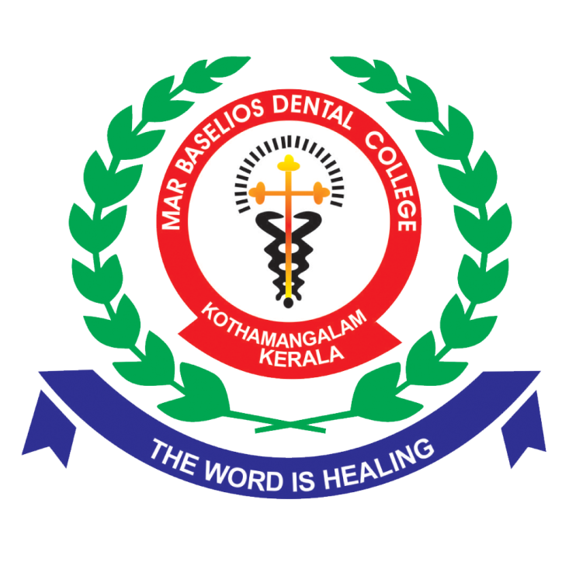

**Staff Selection and Appointment**

At MBDC, the selection and appointment of both teaching and non-teaching staff members are carried out through a transparent and merit-based process. The Principal communicates staff vacancies to the Board of Directors, which then channels the information to the Staff Selection Board (SSB) of Mar thoma Cheriya Pally. The SSB publishes notifications in the media and conducts interviews to identify suitable candidates who meet the strict merit-based criteria.

Once selected, newly appointed staff members undergo an initial probationary period. Upon completion of this period, their performance is evaluated comprehensively. If their performance is deemed satisfactory, the appointment is made permanent, ensuring the recruitment of qualified and capable individuals.