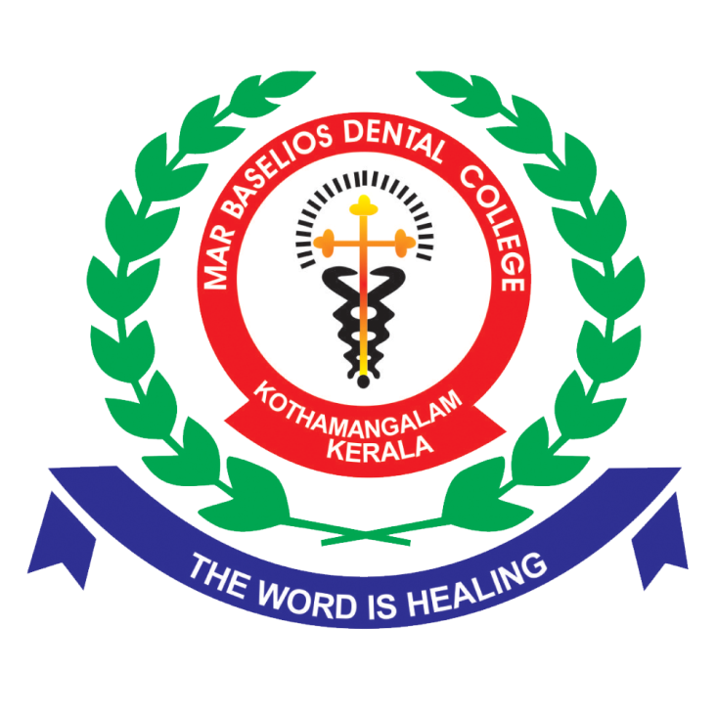

**Recreation**

MBDC recognizes the significance of recreation in maintaining a healthy work-life balance. The college offers various cultural and sports recreational opportunities within the campus premises. Additionally, recreational trips are organized, allowing staff members to unwind, bond, and rejuvenate.